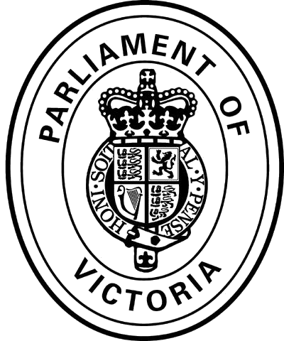 | Family and Community Development Committee  Media Release

From Committee Chair, Ms Georgie Crozier, MP

13 November 2012

Committee continues its work

Committee Chair, Ms Georgie Crozier, MP said the Inquiry into the handling of child abuse by religious and other organisations will continue.

‘The Inquiry's work thus far has bought to light important revelations that have been key to the Federal Government deciding to call a royal commission,’ she said.

‘From our part, a significant amount of work has already been undertaken and there is more we can achieve, but we obviously need further detail of the federal inquiry, including its terms of reference, before making any changes to our work.

‘We are focused specifically on the handling on child abuse that happened in Victoria and the outcomes of our Inquiry would have implications for state legislation and agencies.

‘Our work is too important to just stop and we are not going to compromise investigations that are already underway, and in which we are making much progress.’

Next hearings are scheduled for Friday 23 November and Monday 26 November in Melbourne.

Further assistance:

- For further information regarding the Inquiry, please see the Committee website at http://www.parliament.vic.gov.au/fcdc/inquiry/340 or phone (03) 8682 2843

- Help for victims - including support in preparing for and attending a public hearing and linking people to local support groups and services - is available through the Victims of Crime Helpline on 1800 819 817

- For media queries by journalists, please contact Amanda Kennedy on 0409 890 658

